VISION COLLEGE OF NURSING, YELGAON,BULDANA
TEACHING FACULTY
Sr  No | Name | Designation | Speciality | Photo
1. | Mrs. Meena Gangadhar Bokan | Principal | M.Sc.(N)  Community Health Nursing | 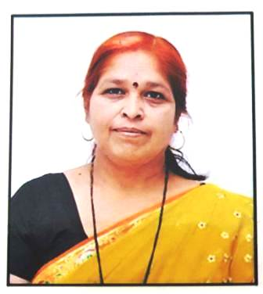
2. | Mrs. Swati Rohan More | Vice principal | M.Sc.(N)  Medical Surgical Nursing | 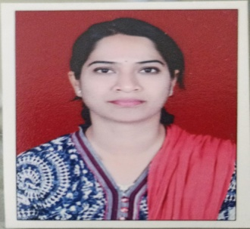
3. | Ms.Rohini B. Pawar Kulkarni | Associate Professor | M.Sc.(N)  Medical Surgical Nursing | 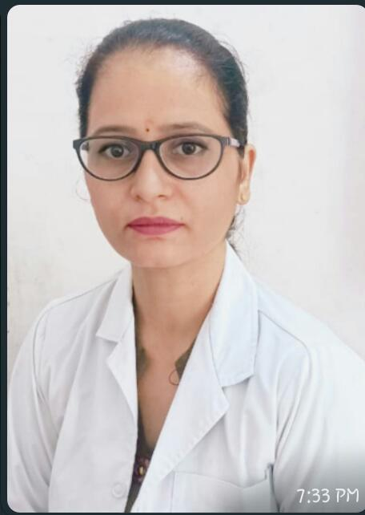
4. | Ms.Shubhangi Dhanvij | Assistant Professor/  Lecturer | M.Sc.(N)  Mental Health Nursing | 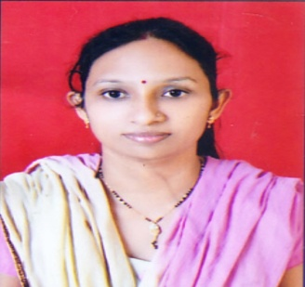
5. | Mr. Arun Pandurang Lokhande | Associate Professor/ Lecturer | M.Sc.(N)  Medical Surgical Nursing | 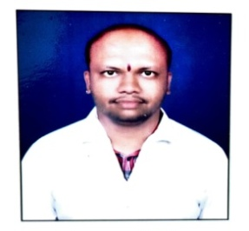
6. | Ms. Seema Dilip Hiwale | Assistant Professorl Lecturer | M.Sc.(N)  Child Health Nursing | 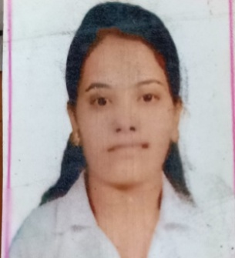
7. | Mr. Yogesh Sanjay Tathe | Tutor/Clinical Instructor | Nursing | 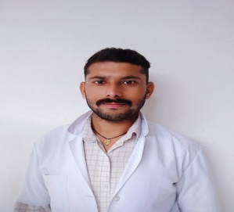
8. | Ms. Sonali Natha Khillare | Tutor/Clinical Instructor | Nursing | 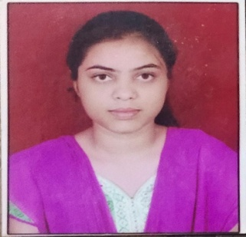
9. | Mr. Shaikh Wasim Shaikh Hakim | Tutor/Clinical Instructor | Nursing | 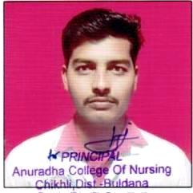
10. | Mr. Saurabh Anil Patil | Tutor/Clinical Instructor | Nursing | 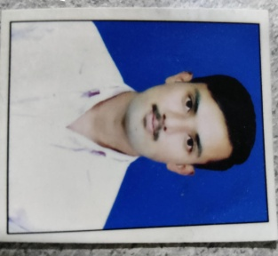
11. | Ms. Sujata Gupta | Tutor/Clinical Instructor | Nursing | 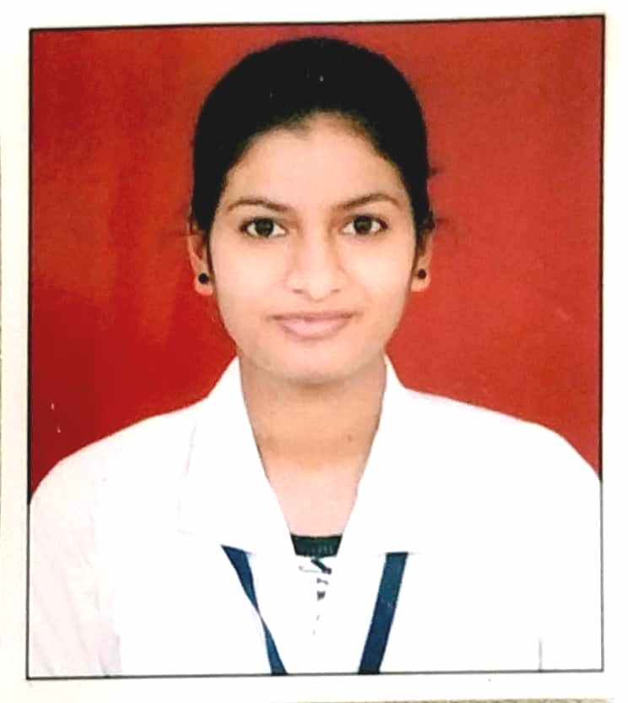
12. | Ms. Monica Rajesh Nirmal | Tutor/Clinical Instructor | Nursing | 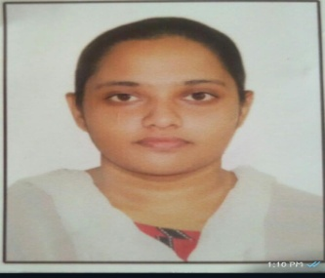
13. | Ms. Sumreen Begum Mukhtar Pathan | Tutor/Clinical Instructor | Nursing | 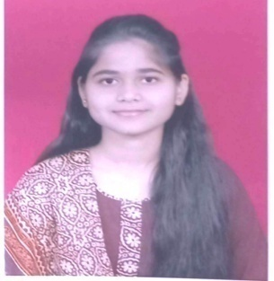
14. | Ms. Dipali Kharat | Tutor/Clinical Instructor | Nursing | 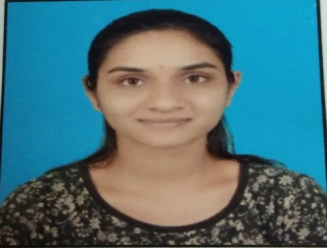
15 | Mr. Shubham Umbare | Tutor/Clinical Instructor | Nursing | 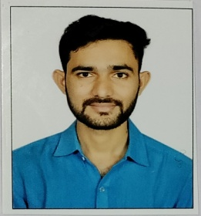
16. | Mr. Akash P. Sanap | Tutor/Clinical Instructor | Nursing | 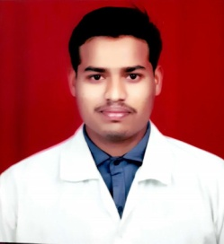
17. | Mr. Sayed Umed Sayed Lukhman | Tutor/Clinical Instructor | Nursing | 